Header ( Toolbar, Divider, icons, Badge )

1. Import Toolbar

Instead of <Div> we will use toolbar

Inside header.js call toolbar

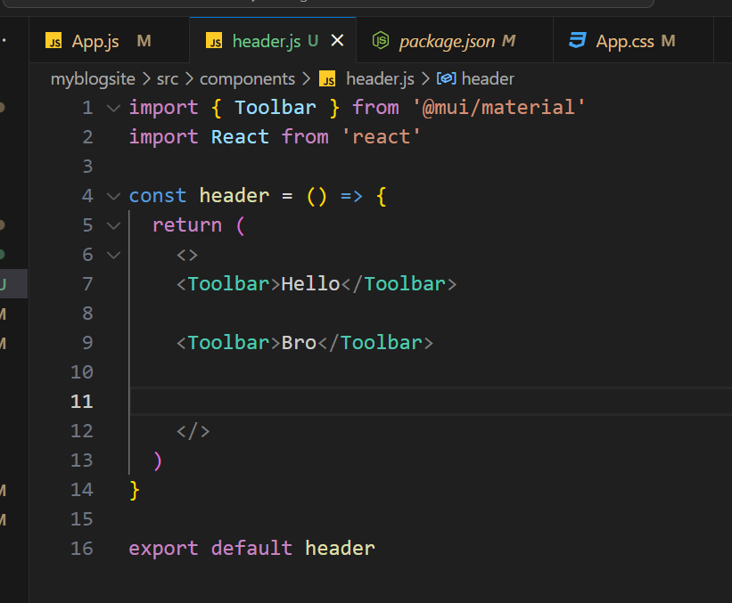

O/P

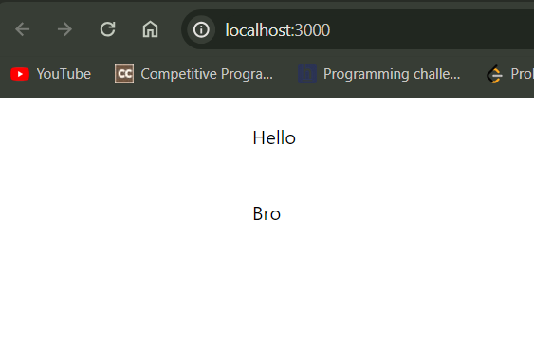

1. Import <Divider/>

The Divider component provides a thin, unobtrusive line for grouping elements to reinforce visual hierarchy.

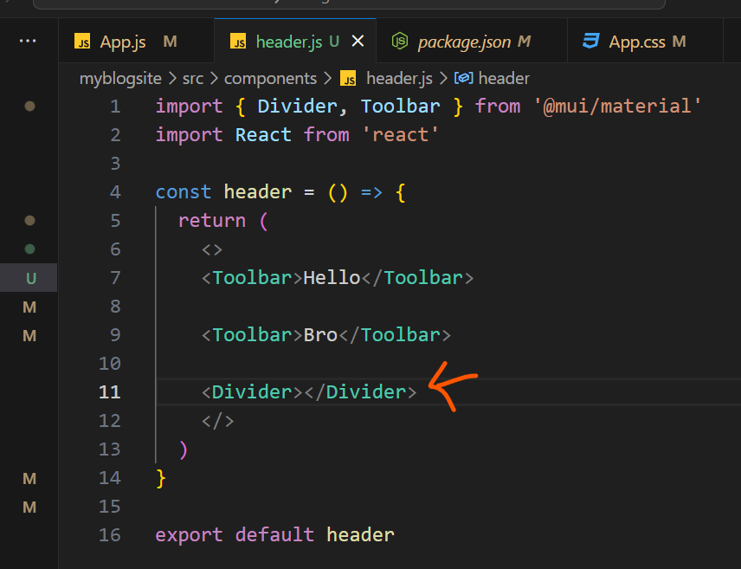

O/P

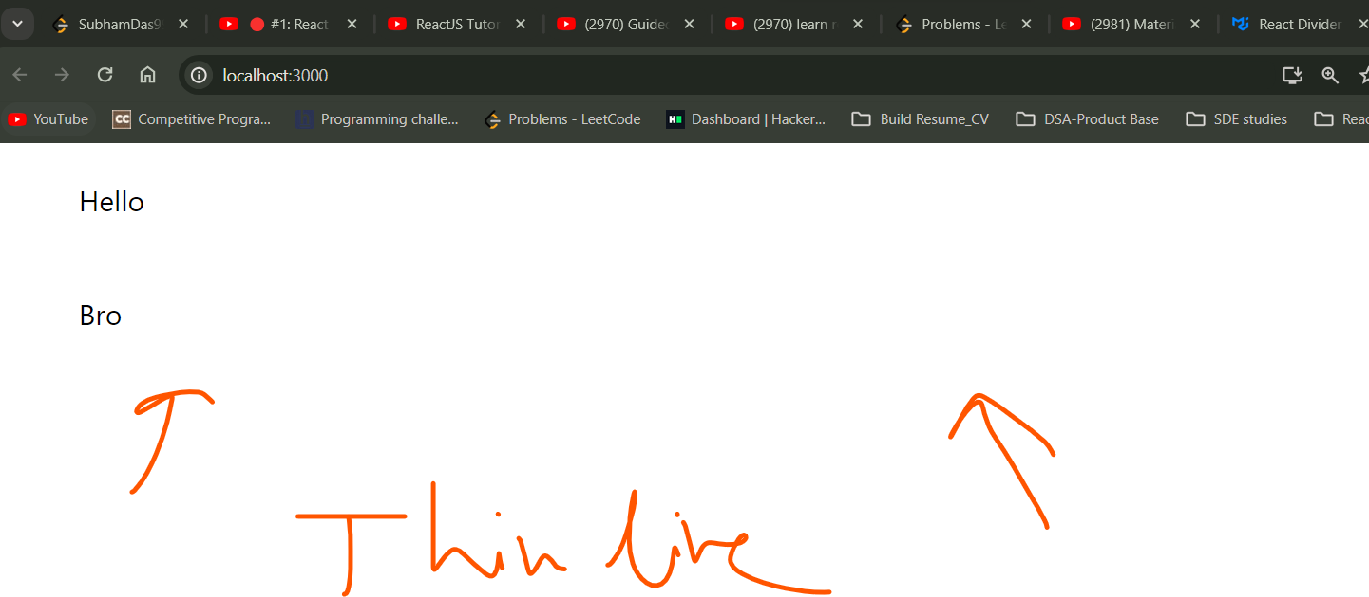

Now inside 1st Toolbar we will keep bellow 4 things

Menu button, Name, noti icon , profile icon

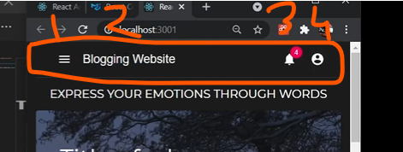

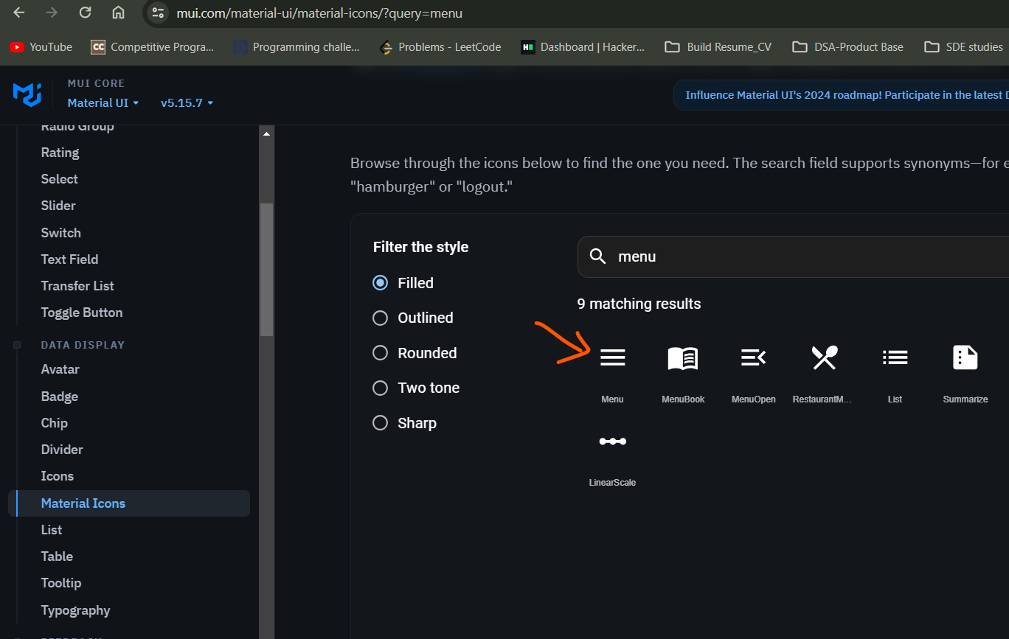

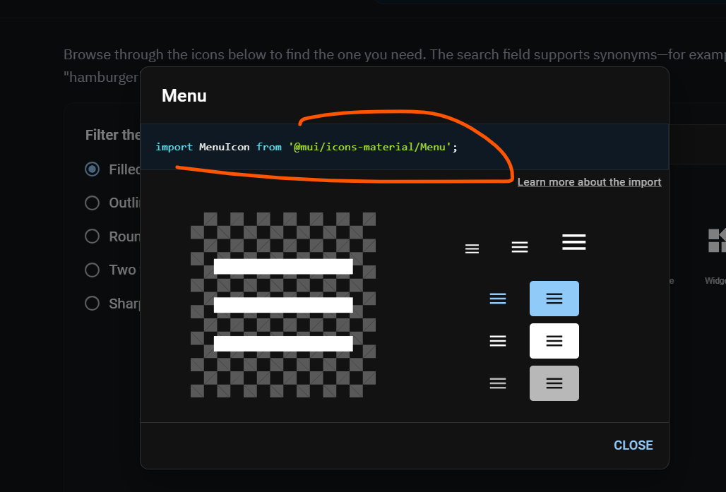

All icons must come inside <IconButton>

This way you need to import and call

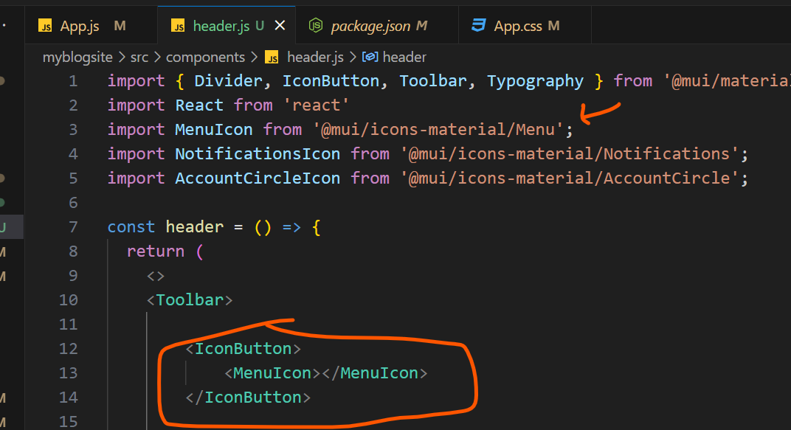

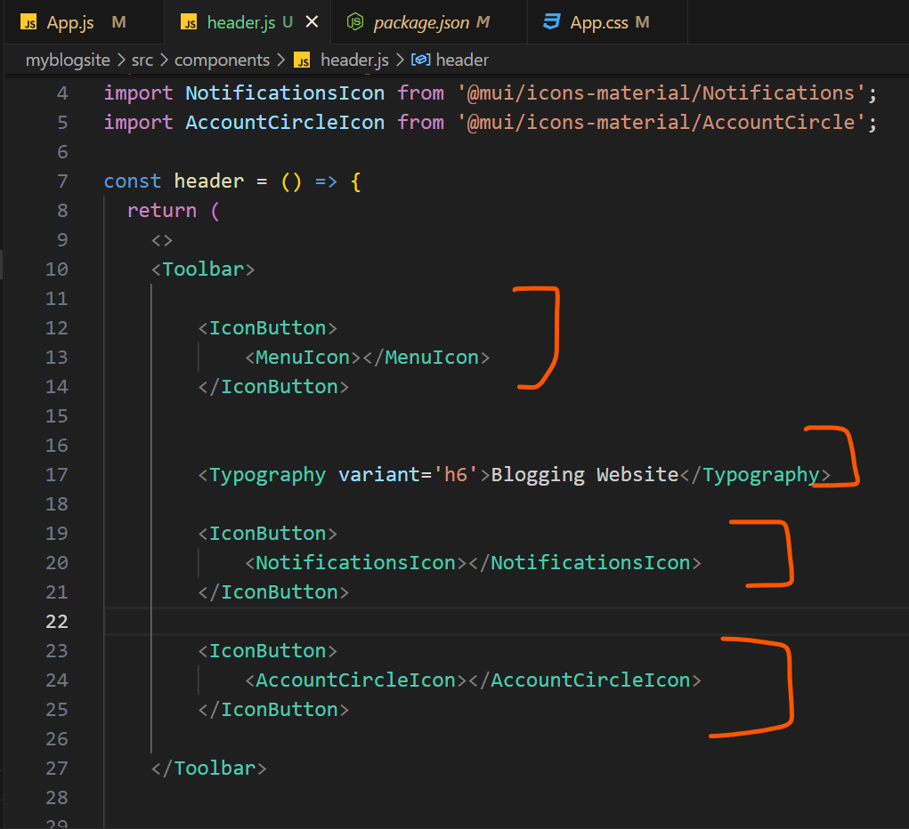

O/P

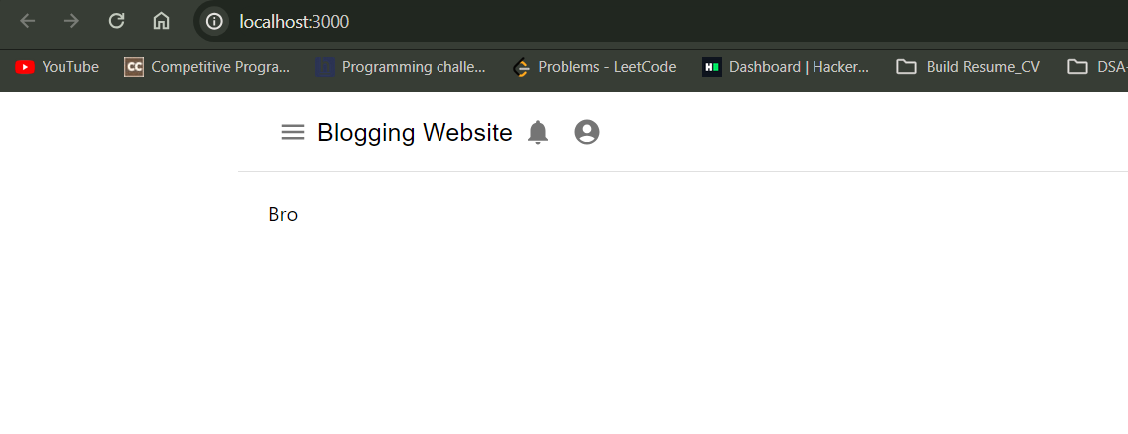

This is called badge

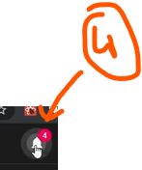

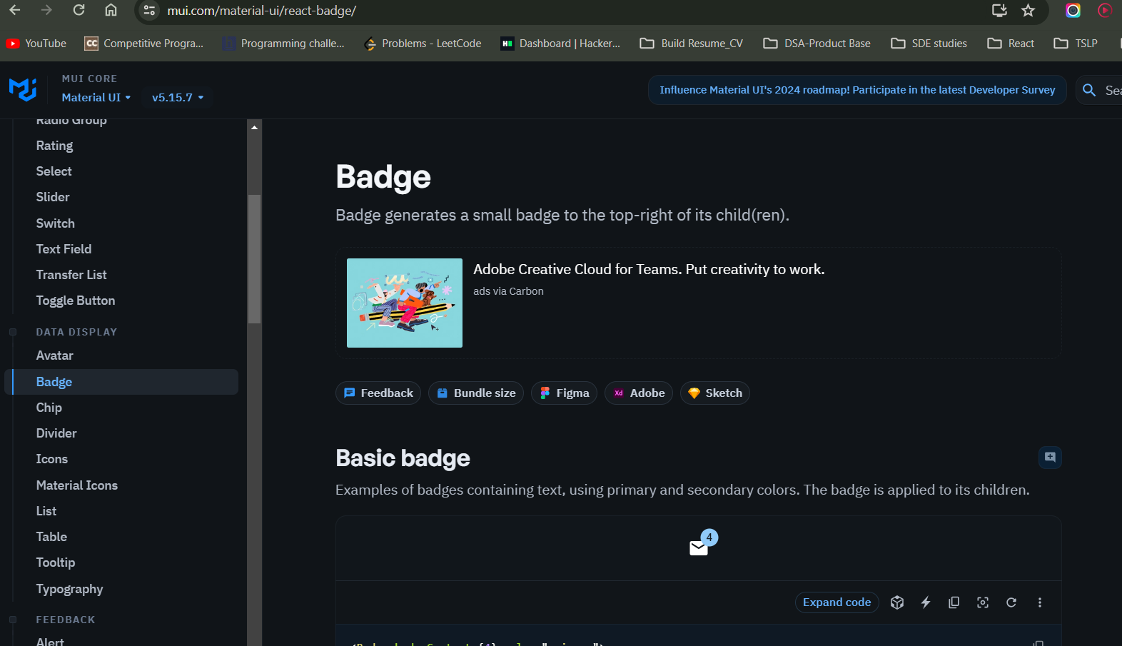

Wrap any icon what ever you want inside badge

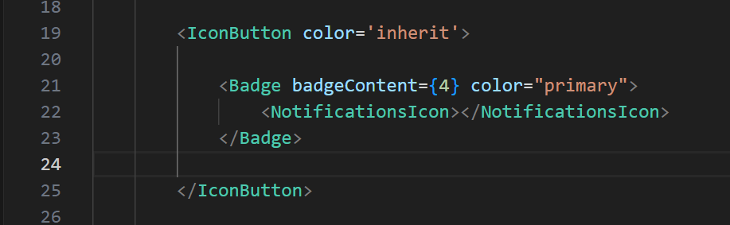

O/P

